УО «Белорусский государственный университет информатики и радиоэлектроники»

Кафедра ПОИТ

Отчет по лабораторной работе №1

по предмету «Архитектура компьютерной техники и операционных систем»

Вариант 2

Выполнил:

Бражалович А.И.

Проверил:

[Аврамец](https://iis.bsuir.by/employees/d-avramets) Д.В.

Группа 351004

Минск 2024

**Дешифратор**

Таблица истинности

|  |  |  |  |  |  |  |  |  |  |  |  |  |  |  |  |  |  |  |  |  |
| --- | --- | --- | --- | --- | --- | --- | --- | --- | --- | --- | --- | --- | --- | --- | --- | --- | --- | --- | --- | --- |
| X3 | X2 | X1 | X0 |  | Y0 | Y1 | Y2 | Y3 | Y4 | Y5 | Y6 | Y7 | Y8 | Y9 | Y10 | Y11 | Y12 | Y13 | Y14 | Y15 |
| 0 | 0 | 0 | 0 |  | 1 | 0 | 0 | 0 | 0 | 0 | 0 | 0 | 0 | 0 | 0 | 0 | 0 | 0 | 0 | 0 |
| 0 | 0 | 0 | 1 |  | 0 | 1 | 0 | 0 | 0 | 0 | 0 | 0 | 0 | 0 | 0 | 0 | 0 | 0 | 0 | 0 |
| 0 | 0 | 1 | 0 |  | 0 | 0 | 1 | 0 | 0 | 0 | 0 | 0 | 0 | 0 | 0 | 0 | 0 | 0 | 0 | 0 |
| 0 | 0 | 1 | 1 |  | 0 | 0 | 0 | 1 | 0 | 0 | 0 | 0 | 0 | 0 | 0 | 0 | 0 | 0 | 0 | 0 |
| 0 | 1 | 0 | 0 |  | 0 | 0 | 0 | 0 | 1 | 0 | 0 | 0 | 0 | 0 | 0 | 0 | 0 | 0 | 0 | 0 |
| 0 | 1 | 0 | 1 |  | 0 | 0 | 0 | 0 | 0 | 1 | 0 | 0 | 0 | 0 | 0 | 0 | 0 | 0 | 0 | 0 |
| 0 | 1 | 1 | 0 |  | 0 | 0 | 0 | 0 | 0 | 0 | 1 | 0 | 0 | 0 | 0 | 0 | 0 | 0 | 0 | 0 |
| 0 | 1 | 1 | 1 |  | 0 | 0 | 0 | 0 | 0 | 0 | 0 | 1 | 0 | 0 | 0 | 0 | 0 | 0 | 0 | 0 |
| 1 | 0 | 0 | 0 |  | 0 | 0 | 0 | 0 | 0 | 0 | 0 | 0 | 1 | 0 | 0 | 0 | 0 | 0 | 0 | 0 |
| 1 | 0 | 0 | 1 |  | 0 | 0 | 0 | 0 | 0 | 0 | 0 | 0 | 0 | 1 | 0 | 0 | 0 | 0 | 0 | 0 |
| 1 | 0 | 1 | 0 |  | 0 | 0 | 0 | 0 | 0 | 0 | 0 | 0 | 0 | 0 | 1 | 0 | 0 | 0 | 0 | 0 |
| 1 | 0 | 1 | 1 |  | 0 | 0 | 0 | 0 | 0 | 0 | 0 | 0 | 0 | 0 | 0 | 1 | 0 | 0 | 0 | 0 |
| 1 | 1 | 0 | 0 |  | 0 | 0 | 0 | 0 | 0 | 0 | 0 | 0 | 0 | 0 | 0 | 0 | 1 | 0 | 0 | 0 |
| 1 | 1 | 0 | 1 |  | 0 | 0 | 0 | 0 | 0 | 0 | 0 | 0 | 0 | 0 | 0 | 0 | 0 | 1 | 0 | 0 |
| 1 | 1 | 1 | 0 |  | 0 | 0 | 0 | 0 | 0 | 0 | 0 | 0 | 0 | 0 | 0 | 0 | 0 | 0 | 1 | 0 |
| 1 | 1 | 1 | 1 |  | 0 | 0 | 0 | 0 | 0 | 0 | 0 | 0 | 0 | 0 | 0 | 0 | 0 | 0 | 0 | 1 |

СДНФ

$Y0= \overline{x3x2x1x0}$

$Y1= \overline{x3x2x1}x0$

$Y2= \overline{x3}\overline{x2}x1\overline{x0}$

$Y3= \overline{x3x2}x1x0$

$Y4= \overline{x3}x2\overline{x1x0}$

$Y5= \overline{x3}x2\overline{x1}x0$

$Y6= \overline{x3}x2x1\overline{x0}$

$Y7= \overline{x3}x2x1x0$

$Y8= x3\overline{x2x1x0}$

$Y9= x3\overline{x2x1}x0$

$Y10= x3\overline{x2}x1\overline{x0}$

$Y11= x3\overline{x2}x1$ x0

$Y12= x3x2\overline{x1x0}$

$Y13= x3x2\overline{x1}x0$

$Y14= x3x2x1\overline{x0}$

$Y15=x3x2x1x0$

Скриншот схемы

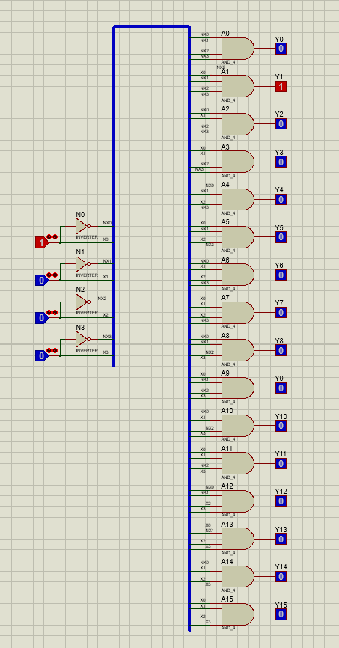

Временная диаграмма

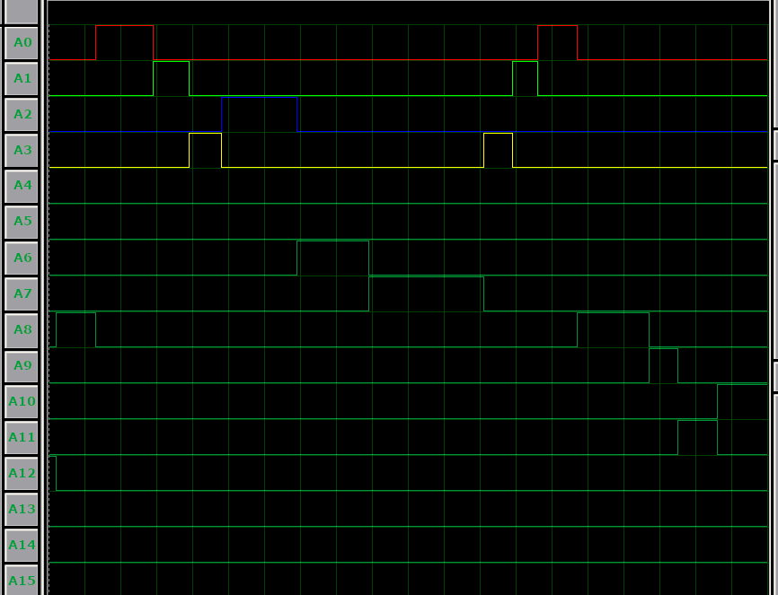

Y0..Y15 – A0..A15

**Четырёхразрядный сумматор**

Скриншот схемы

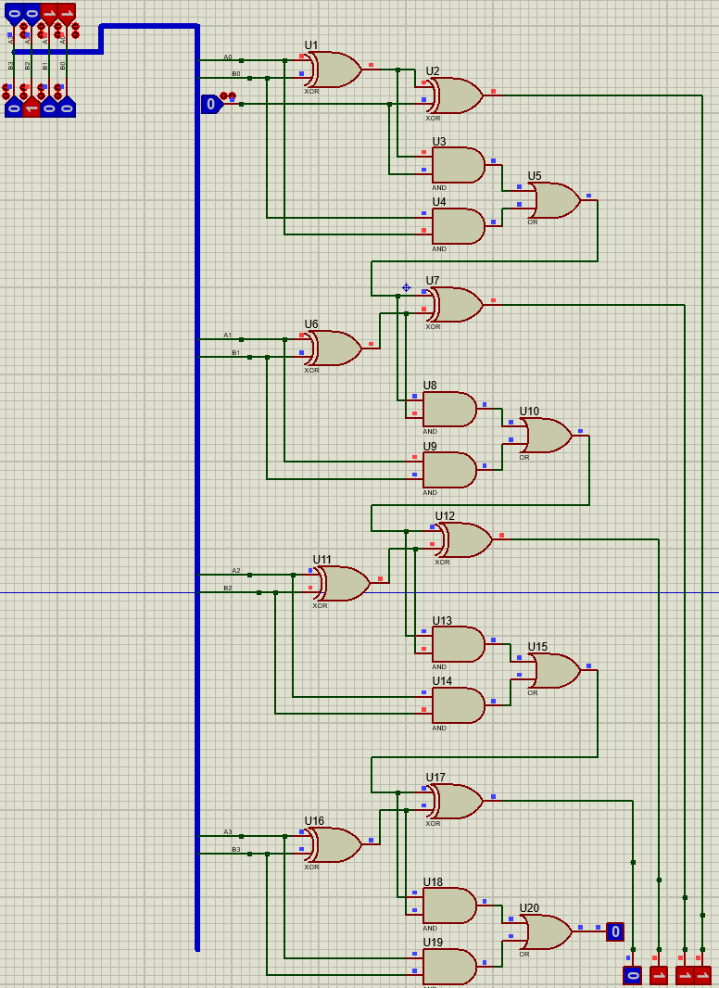

Временная диаграмма

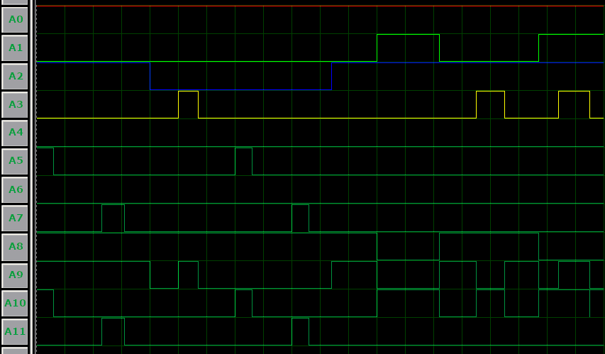

A0..A3 – A0..A3, A4..A7 – B0..B3, A8..A11 – Y0..Y3

­

**Двуступенчатый D-тригер**

Скриншот схемы

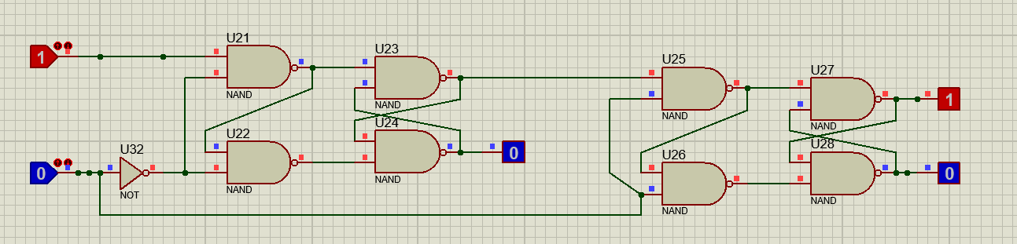

Временная диаграмма

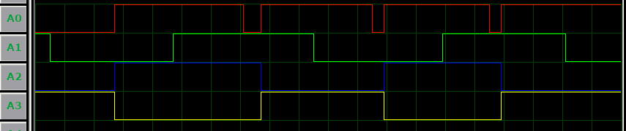

A0 – C, A1 – D, A2 – Q, A3 – $\overline{Q}$

**Риверсивный регистр сдвига**

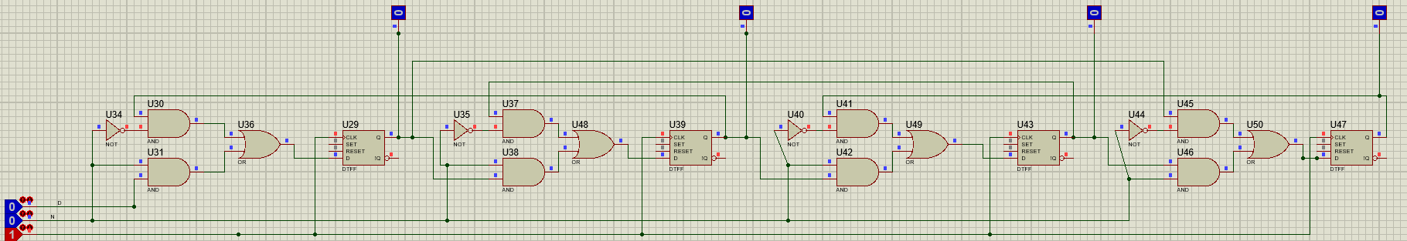

Временная диаграмма

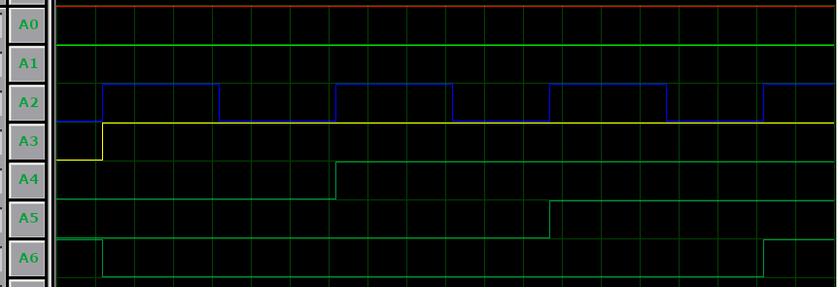

A0 – D, A1 – N, A2 – C, A3..A6 – Q1..Q4